FIRST ANNUAL REPORT covering 2016 to 2018
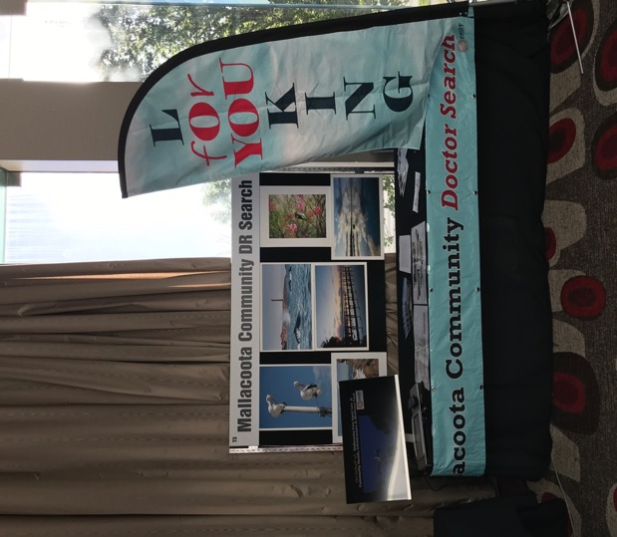

Summary of Key Activities October 2017 -October 2018
- October -Attendance at conferences ACRRM Melbourne, RACGP Sydney
- October to present - Liaison with RVTS
- November- Engagement of Dr. Emily Butlin
- December/ January - Summer markets
- February -Commencement of Dr Emily Butlin
- November /December/ January - Negotiation for and engagement of Dr Mubashar Sherazi including a fortuitous visit to meet his family in Calgary Canada in December 2017
- February -Commencement of Dr Mubashar
- February – Formal Engagement of Group HIS to develop new medical centre
- February to present – negotiations with EG Shire and CFA re building requirements
- Announcement of recipients of RIPERN scholarship made possible by Mallacoota Fundraising Group
- April - Easter market
- May to present - Approaches to MDHSS via new CEO to discuss co-operation
- April to present - Applications for grants covering After Hours, Mental Health and Chronic Diseases.
- Development of arrangements with Bega Valley Medical Clinic re possible extension of “Teen Clinic” to Mallacoota and Cann River
- Extended work on the future for residential aged care facility, residential villas, High Care nursing beds, Trauma facilities and Allied Health Specialist equipment facility.
- May Contact from community Yarram and advice on our processes
- April Attendance at GPHN Project Advisory Group Orbost
- Contribution to Business for Doctors for DR SEARCH UK program
- June- First meeting of Local Health Planning Committee
- June to present – ongoing negotiations with GPHN and MMC re AH care and MH plan
- Presentation to the Philanthropic Charities breakfast re the work of CHIRF
- September – second meeting of Local Health Planning committee
CHIRF HEALTH INITIATIVES 2016 - 2018– To the rescue and then beyond!
The Mallacoota Community Health, Infrastructure and Resilience Fund Inc. (CHIRF) is a registered tax-deductible charity which was formed in May 2016, originally to ensure that the district retained its medical practice. This is a three-part briefing on what CHiRF and the community has achieved and the challenges we are facing for 2019.
CRISIS 2016 – IT WAS ONLY TWO YEARS AGO WHEN…
CHIRF’s community agenda was shaped by the imminent crisis of losing its vital medical practice. Since then things have stabilised through its Doctor Search program which initially built up a pool of locum doctors and then had success in finding two longer term GPs. CHiRF’s with its focus on primary medical support issues affecting the community, and with the support of our sister charity, MIAC, saw the development of plans and the beginning of construction of a new medical centre on the land owned by MIAC. Each body contributed $300,000 to the project, MIAC from its fundraising efforts over the years, and CHiRF from a federal government grant.
Following a huge effort, CHIRF achieved tax deductibility status as a health promotion charity. This is notoriously difficult to get. This DGR (Deductible Gift Recipient) status means that CHiRF could improve medical facilities and employment opportunities.
Looking forward to 2019 CHiRF’s community development initiatives have attracted another $246,000 in grants which will enable it to support:
- a visiting psychologist
- A Teen Mental Health Clinic
- The upgrading of the medical services to enable GPs to refer patients to other allied health professionals
- With MIAC’s help, the preliminary work on a high-care nursing centre on behalf.
- Also with MIAC’s assistance, CHiRF would like to commence preliminary work on a Residential Aged Care facility
In particular, CHiRF is exploring new ways of reducing multiple chronic disease hospitalisation out of hours.

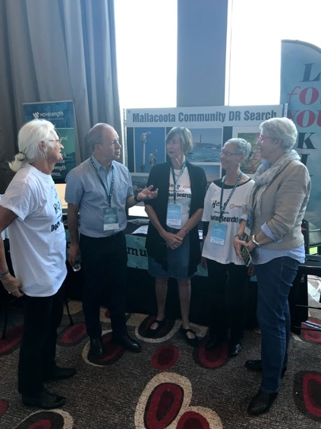

CHiRF’s achievements have given Mallacoota’s profile a boost nationally with Federal and State politicians and their administrators. We are also being noticed by philanthropic organisations who are intrigued by our district’s growing profile within the health and health services industry.
Despite setbacks, CHiRF also managed to develop a new model of health care delivery based on community-driven initiatives. This is now being accepted by health authorities and being copied by several other remote districts facing health and medical challenges.
UPGRADING MALLACOOTA’S MEDICAL PRACTICE TO ATTRACT AND IMPORT GPs
One real innovation was the re-qualifying of Dr Sara Renwick-Lau in order to upgrade her practice to a remote medical training facility. Her completion of these qualifications enabled us to make GP registrar, Dr Emily Butlin, the first addition to our family in February. However Emily will to move onto another rotation later this year. This raises issues of attracting Registrars to such a remote environment when the AGPT region rules make access to Registrars very limited for us. An issue CHIRF will be pursuing at higher level.
Fortuitously the Mallacoota Doctor Search initiative also attracted Dr Mubashar and his family via a Remote Vocational Training Scheme (RVTS) scholarship that CHIRF pressed for in 2016 at the Rural Health Conference. CHIRF was delighted to negotiate with Dr Mubashar and RVTS, a three-year contract with to work here.
A lot of effort went into meeting the immigration requirements. CHIRF also lobbied for, and received support from GPHN to help make it all happen.
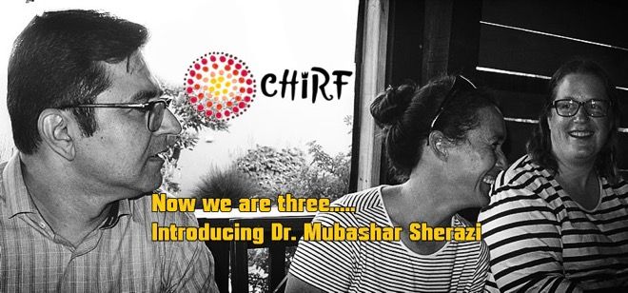

REMOTE CHALLENGES, COMMUNITY SOLUTIONS
Our first major initiative for 2019 is managing the construction of the new medical centre. The major delay in the commencement of building was the upgrading of the original Bushfire Attack Level (BAL) assessment from 12.5 to 20 to a BAL of 40. This was a requirement of the Country Fire Authority.
This meant an extra $70,000 on the project’s cost and could have meant its end. Fortunately, MIAC was able to convince the Bendigo Bank to provide a mortgage to $170,000 in addition to their initial investment.
In order to ensure the building will have a solar capacity and back up batteries, Jill Mackieson put her head down and organised a charity auction for CHIRF. It was extremely well organised and $11,000 was raised. $15,000 to go if we are to achieve the maximum potential of the building. Money also needs to be found for chairs for the new centre. So, the fund-raising is not over!
Our Mallacoota Fundraising Group were marvellous in contributing much needed funds for essential equipment. All the equipment CHiRF buys is to minimise the need for patients (that’s you!) to have to travel up or down the coast to have minor medical procedures done. Last year their efforts led to the almost half the cost towards the purchase of the Ultra Sound equipment. Many others have made large contributions as well. CHiRF has a policy of not identifying individuals in order to avoid any conflict with the medical protocols relating to gifts. You know who you are and the community thanks you.
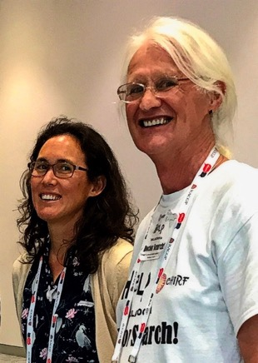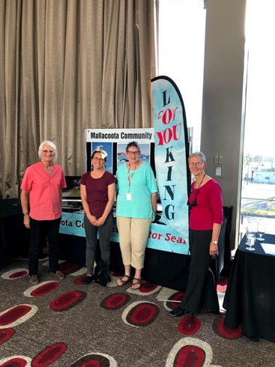

MALLACOOTA’s NEWEST MEDICAL BUILDING
CHIRF continued its work managing the planning and construction of the medical centre for MIAC. MIAC’s unstinting support, flexibility and patience in encouraging us to break new ground was a major factor in this achievement.
You will now see the foundations are in and we are moving rapidly to an estimated completion date of about March. We have a great relationship with Southern Cross Developers, the construction contractors and with Group HiS who performed the design and planning approval work.
As well almost all the work on this specialist medical building was performed by local tradespeople.
WITH GPHN DISTRICT REACHES OUT TO CANN RIVER
CHIRF continued its work on other aspects of primary health care delivery to this community and with an eye on our friends in Cann River. Dr Sara has opened up the practice in Cann River one day a fortnight taking over from a desultory service from Orbost Regional Health which confronted similar problems – no Doctors. The ravages of government cuts on the MBS made it imperative that practices attract a large number of patients.
We committed to this with support from the Gippsland Primary Health Network. Our continuing challenge for 2019 is to ensure government agencies don’t treat the private practice as just another welfare agency.
As well, CHIRF in consultation with the Mallacoota Medical Practice won a $136,000 grant from the Foundation for Rural and Remote Renewal (FRRR) for money to support an administrator for CHIRF, support for a visiting psychologist, upgrade to Telehealth facilities and development of support for teenagers in Mallacoota and Cann River.
Did you know, CHIRF has no employees. We are volunteers and as a result of the FRRR Grant we are now able to employ Project Manager. We have a contract in preparation for a visiting psychologist and for an allied health assistant. They will be employed by CHIRF under contract to MMC.
WHAT ABOUT AFTER HOURS?
Not content with that, working with MMC we put in for a grant from GPHN to reintroduce after hours care supported by the Doctors and Nurses. A new model of care for remote communities. But it was knocked back. We are watching now with interest how GPHN are going to handle the clear need. We put in a mountain of empirical evidence supporting our proposal. GPHN have gone for an unproven model that we intuitively doubt will work. Let’s see, we hope nobody suffers with experimentation.
However GPHN offered CHIRF a supplementary grant to support work to improve the day care of multiple chronic disease patients to minimise the risks of after hours hospitalisation. This is a project that Robin has been battling back and forward with GPHN for some time as part of an interest they turned him towards. CHIRF under Robin’s direction created a comprehensive document called Mallacoota Health Check. It serialises the health delivery to Mallacoota, analyses the shortcomings and looks carefully at the key health issues a community such as ours faces. Work in progress. We will make available online in 2019.

CHIRF HEALTH INITIATIVES LEADING TO 2019 –MENTAL HEALTH AND AGED CARE MATTERS
WHAT ABOUT TEEN HEALTH IN 2019?
It was brought to CHiRF’s attention that there is an issue in the community with the health of some of the young people in the area. After some research, which confirmed this, and with the support of the Medical Centre, we approached GPHN (Gippsland Primary Health Network) for assistance. Our research led us to the work of Dr Duncan MacKinnon of the Bega Valley Medical Practice which has a teen clinic operating. Dr MacKinnon realised following of a spate of suicides in his area that much more needed to be done and he designed a program for the youth small communities called the Teen Clinic. Now with, with Commonwealth support there are Teen Clinics in Eden, Moruya, Bega and Merimbula. With our friend and mentor, Stan Stavros of SBM Accounting Services, CHIRF has built a solid relationship with Dr MacKinnon and we are very pleased to announce that following GPHN’s financial support, Mallacoota will soon also have a Teen Clinic. A Teen Clinic is designed for small practices, small communities, and offers total privacy and confidentiality.
It will initially involve specially trained nurses with immediate access to the doctor on duty. It will have the services of a psychologist and hopefully a mental health worker in the not too distant future.
We are working with the Mallacoota P-12 College to make this happen and expect to start in first term 2019.
- RESIDENTIAL AGED CARE 2019 - DREAM A BIG DREAM
This important project has not been forgotten and we shall continue to work with MIAC to progress the establishment of a residential aged care facility.
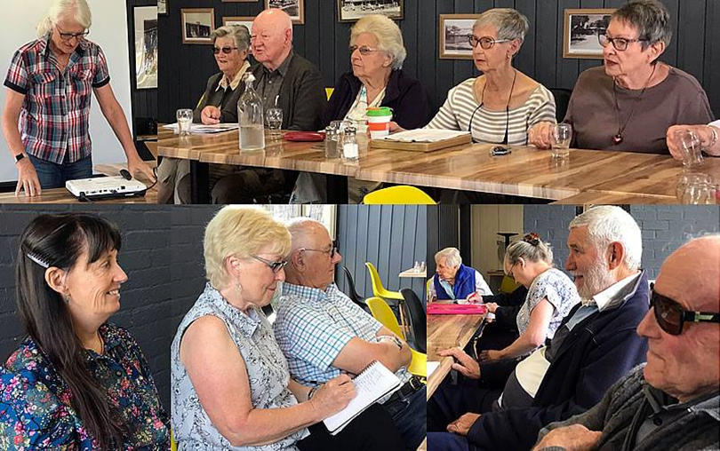
CHiRF has a separate project underway for a 25 bed High Care Facility. We are working with a specialist accounting firm and are looking for partners in the project. It is a pipe dream, so far, but we believe with the will and drive that CHIRF has been able to bring to other projects, it will happen.
.
- HOW DOES CHIRF WORK?
You’ve probably realised already that it is not a traditional model of an organisation, but it IS very effective. Other remote communities are aware of our progress and it has attracted national and international attention. CHiRF was recently asked to make a presentation to a large gathering of philanthropic charities, one of whom will shortly be using us as an example of their support for community work.
We have also been invited to make a presentation to the National Rural Health Conference in Hobart next year and to the ‘Business for Doctors’ Conference 2019 in Brisbane.
All this lobbying and exposure is necessary to ensure Mallacoota gets its fair share of the National and State health budgets, as much as possible from charitable foundations, and a supply of medical and allied professionals wanting to come here.
EQUIPMENT

CHIRF has invested in a range of equipment for the medical centre to ensure patients can be handled in Mallacoota for minor procedures and not have to make the long trek to other not so nearby places. Merimbula, Bega, Bairnsdale.
All equipment remains the property of CHIRF/the community. During our period we have invested in
- A generator to ensure that the practice can operate during the frequent outages and vaccines not spoiled. (jointly with MIAC)
- Loupes
- Vaccine Fridge
- Blood Pressure Monitors
- Ultra Sound
- Operating Lights
- Ipad for telehealth
- Coagucheck point of care blood test
- Alive Cor Kardia smart phone device for cardiac arrythmia

WOULD YOU LIKE TO WORK WITH CHIRF IN 2019 AND HELP US ACHIEVE OUR GOALS?
Did you know CHIRF is not a closed shop? Membership is open to anyone prepared to work hard with a small team. The emphasis is “work with”. Nobody on CHIRF is just a member, everyone makes a contribution which can range from a few to many hours a week. We are all on a learning curve in CHIRF and your efforts, whatever you are able to give, will be most appreciated by us and by your community.
If you are willing to help, ring Robin (ph.0417271852) for a chat

Dr Tricia Hiley resigned as a Board Member in December 2017 and Graham Clark in May 2017. Both have served from the inception of CHIRF in May 2016 and gave unstinting energy and support mental and physical.
The Current Committee comprises Robin Bryant President Secretary, Sue Brown VP Dr Search, Linda Bruce VP John Hilvert Member (Media). Accounting Services are provided by SBM Stavros Albury and business advice from the Principal Mr Stan Stavros.

